OFFICIAL COORDINATION REQUEST FOR
NON-ROUTINE OPERATIONS AND MAINTENANCE

COORDINATION TITLE - 13 IHR 02 Water up delay - Adult Trap
COORDINATION DATE - 2/27/2012
PROJECT - Ice Harbor Lock and Dam
RESPONSE DATE – Responses are requested ASAP

Description of the problem – Lead based paint has been discovered in the Ice Harbor south shore fish ladder in the area where the new adult salmonid trap is being installed. In order to finish installation of the in-ladder components of the new adult salmon trap, a special remediation crew needs to be brought in to remove this paint in specific areas prior to returning the adult ladder to service. This remediation and subsequent final construction activities will lead to watering up the south shore ladder and returning it to service on 8 March but NLT 11 March if complications do occur. Schedule delay is as follows:
2 days for submittals & reviews (Feb 28th & March 1)
2 days to abate lead removal (Mar 2 & 3)
2 days for welding & inspection (Mar 5 & 6)
1 day to recoat guide channel (Mar 7)

Type of outage required – The Ice Harbor south shore adult ladder is currently unwatered for winter maintenance and installation of the new adult trap, originally anticipated to be returned to service on 28 February 2013. Due to the delay in completing in-ladder construction as described above, the Corps needs to keep the south shore ladder unwatered until construction activities can be completed, no later than Monday 11 March 2013. The north shore ladder is currently in operation and is expected to continue operating within FPP criteria during this extended south shore ladder outage.

Impact on facility operation – Project staff will need to water-up the shore adult ladder upon completion of paint removal and construction activities on, or before, Monday 11 March 2013 instead of 28 February 2013 as originally scheduled.

Dates of impacts/repairs – The south shore ladder will be kept in its current unwatered state until construction activities are completed and project staff is able to water up the ladder, no later than Monday 11 March 2013. North shore ladder will be in full FPP compliance.

Length of time for repairs – The south shore ladder will be kept unwatered for up to 11 additional days, returning to service NLT Monday 11 March 2013, due to this unforeseen lead paint discovery in the welding area.

Expected impacts on fish passage – Impacts to fish passage are expected to be minimal. The North Shore adult ladder is currently operating within FPP criteria and is expected to continue normal operations throughout the south shore adult ladder outage. Operation of the north shore ladder will continue to provide adult passage past Ice Harbor Dam during this south shore ladder outage.

Adult salmon passage at Ice Harbor dam is low during the March time period with generally only adult steelhead being observed passing the project (Figure 1 & 2) during the first part of the month. In years when March fish passage has been recorded at Ice Harbor, (2007 was the last year of video recording ), 50-130 adult steelhead have been observed passing the project on a daily basis (Figure 3 & 4). While adult fish have generally used the south ladder during March, fish will continue to be able to pass Ice Harbor via the north shore ladder during this south shore ladder outage.

Figure 1. 10 year average adult salmonid passage at ICE (2002-2011)

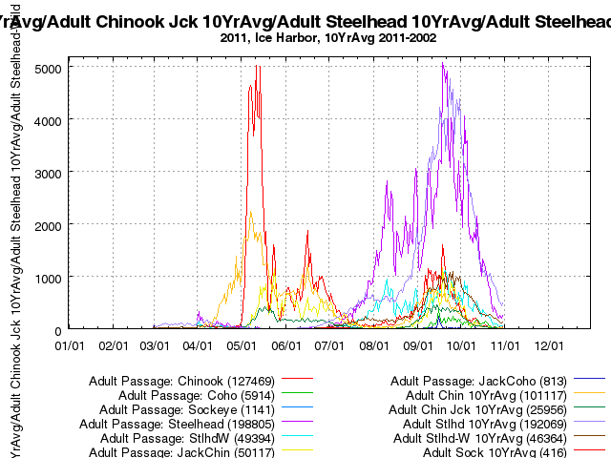

Figure 2. Average adult salmonid passage at ICE; 3/1 to 3/20 (2002-2011)

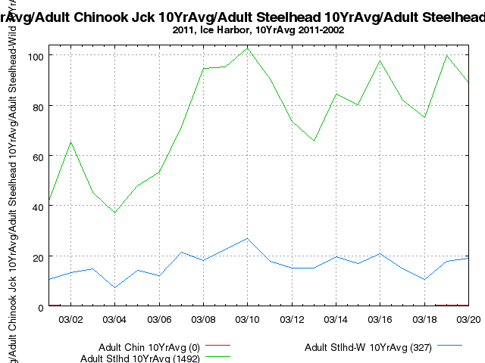

Figure 3. Average daily counts of adult salmonid passage at Ice Harbor Dam South Shore Ladder for 2003-2007 (years with available March data)
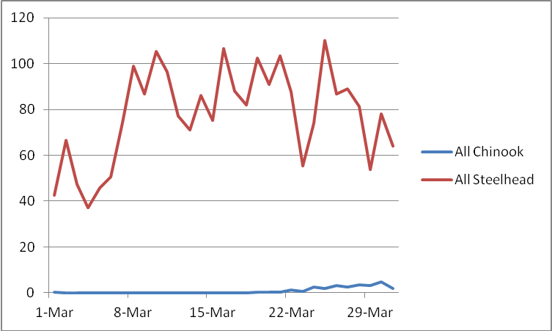

Figure 4. Average daily counts of adult salmonid passage past Ice Harbor Dam North Shore Ladder for 2003-2007 (years with available March data)

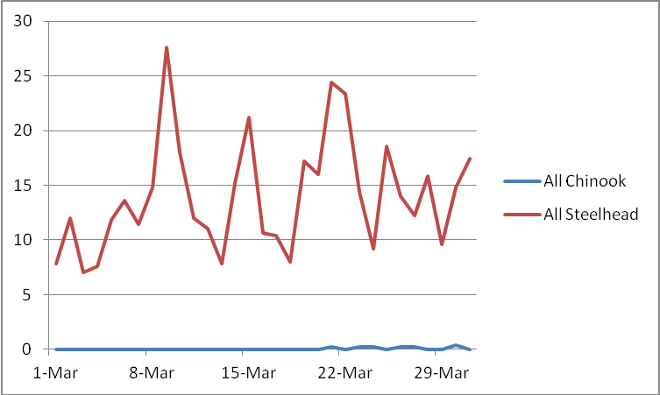

Comments from agencies

March 1, 2013
A telephone conference on 1 March was initiated with NOAA, BPA and Corps to explore ways of providing better attraction to the north shore ladder during the unexpected outage of the south shore ladder. It was agreed to have spillbay #10 (closest to the north shore entrance), open at 1 stop (approx 1.7 kcfs), to provide attraction flow to the north shore ladder between 0600 and 1900 hrs. Also turbine unit priority will change to 1,6,5,4,3,2 to assist in attracting fish towards the north. This action will be effective immediately through 5 March at 1900 hrs. At that time Ice Harbor plant operation will revert back to normal FPP guidelines. Adult fish passage data will be reviewed daily and presented to a conference call to FPOM on Wednesday afternoon for other coordinated actions if needed.

Final results

The above actions in the “Comments from agencies” were implemented as written. The south fish ladder returned to service on March 5, 2013 at approximately 1200 hours.

Review of the adult fish passage video of the north shore ladder count station showed the following passage numbers:

March 1: 15 clipped and 9 non clipped steelhead

March 2: electrical failure at south shore. No video.

March 3: 16 clipped and 18 non clipped steelhead

March 4: 22 clipped and 17 non clipped steelhead

March 5: south shore ladder in service at approx. 1200 hrs

north shore had 11 clipped and 18 non clipped stee;head

south shore had 15 clipped and 9 non clipped steelhead

Please email or call with questions or concerns.
Thank you,

Greg Moody
509-527-7124

